SMART PASSWORD GENERATOR
& Strength Checker

JAVA PROJECT REPORT
Subject: Java Programming
Artificial Intelligence and Data Science
CHAITANYA BHARATHI INSTITUTE OF TECHNOLOGY (CBIT)
Submitted By
Name: Kore Shashank
Roll No: 1601-24-771-115
Section: AID-2
Academic Year: 2026–2027

1. Introduction
The Smart Password Generator & Strength Checker is a simple console-based Java application developed to generate random passwords and evaluate their strength. The application allows users to generate passwords of a specified length using lowercase letters, uppercase letters, numbers, and special symbols. It also enables users to enter an existing password and check its strength based on its length and character combinations.
The project is designed using basic Java programming concepts, including methods, loops, conditional statements, strings, and user input handling. It uses the SecureRandom class to generate random password characters and provides a simple menu-driven interface for users to select different operations. The application does not require a database or a graphical user interface, making it easy to understand, implement, and execute.

2. Objectives
The main objectives of the Smart Password Generator & Strength Checker are:
- To develop a simple password generation application using Java.
- To generate random passwords of a user-specified length.
- To include lowercase letters, uppercase letters, numbers, and special symbols in generated passwords.
- To evaluate password strength based on length and character combinations.
- To classify passwords into Weak, Medium, and Strong categories.
- To apply basic Java programming concepts such as methods, loops, conditional statements, strings, and user input handling.
- To provide a simple menu-driven console interface for easy interaction.
- To improve user awareness about creating stronger passwords for better account security.

3. Features of the Application
- Password Generation: Generates random passwords based on the length specified by the user.
- Character Variety: Includes lowercase letters, uppercase letters, numbers, and special symbols in generated passwords.
- Password Strength Checking: Evaluates the strength of an existing password based on its length and character combinations.
- Strength Classification: Classifies passwords into three categories: Weak, Medium, and Strong.
- Menu-Driven Interface: Provides a simple console menu with options to generate a password, check password strength, and exit the application.
- Secure Random Generation: Uses Java's SecureRandom class to generate unpredictable random characters.
- User Input Validation: Checks the selected menu option and password length to prevent invalid inputs.
- Automatic Strength Evaluation: Displays the password strength immediately after generating a password or checking an existing one.
- Custom Password Length: Allows users to select a password length between 4 and 50 characters.
- Simple and User-Friendly: Uses a console-based interface that is easy to understand and operate.

4. Technologies and Tools Used
Technology / Tool | Purpose
Java | Programming language used to develop the application.
JDK 25 | Java Development Kit used to compile and run the program.
Visual Studio Code | Code editor used for writing and running the Java files.
Scanner | Used to accept user input from the console.
SecureRandom | Used to generate random password characters securely.
String and StringBuilder | Used to store character sets and construct passwords.
Conditional Statements | Used to evaluate password strength and validate user input.
Loops | Used to generate passwords and examine their characters.
Switch Statement | Used to handle the menu options selected by the user.

5. Object-Oriented Programming Concepts Used

5.1 Classes and Objects
The project uses the PasswordGenerator class to implement password generation, password strength checking, and menu operations. Objects of the Scanner and SecureRandom classes are created to accept user input and to produce random characters respectively.

5.2 Constructors
The program does not define a user-defined constructor. Instead, it relies on the default constructors of the library classes it uses: new Scanner(System.in) creates the input reader and new SecureRandom() creates the random number generator.

5.3 Methods
The program is divided into separate methods. The generatePassword() method generates a random password, the checkStrength() method evaluates the strength of a given password, and the main() method controls the execution of the application.

5.4 Encapsulation and Data Handling
The character sets and the random number generator are declared as private static final members, so they cannot be modified from outside the class. Password generation and strength-checking logic are kept in separate methods, and StringBuilder is used to construct and modify the generated password efficiently.
5.5 Control Structures if-else statements validate user input, check the password length, and classify passwords as Weak, Medium, or Strong. The for loop is used to generate password characters, shuffle them, and examine characters during strength checking. The do-while loop repeatedly displays the menu until the user chooses to exit.

5.6 Secure Random Generation
The SecureRandom class is used to generate random characters for passwords, providing stronger randomness than a basic pseudorandom generator such as java.util.Random.

6. Class Description
Class | Purpose | Important Elements
PasswordGenerator | Handles password generation, strength checking, and menu operations. | main(), generatePassword(), checkStrength()
Scanner | Accepts user input through the console. | nextLine()
SecureRandom | Generates random values for password characters. | nextInt()
StringBuilder | Constructs and shuffles the generated password. | append(), charAt(), setCharAt()

7. Working of the Application
- The program starts execution from the main() method in PasswordGenerator.java.
- A Scanner object is created to accept input from the user.
- The main menu displays three options: Generate Password, Check Password Strength, and Exit.
- The user selects an operation by entering the corresponding option number.
- If the user selects Generate Password, the application asks for the desired password length.
- The entered length is validated to ensure it is between 4 and 50 characters.
- The generatePassword() method generates a password using lowercase letters, uppercase letters, numbers, and special symbols.
- The generated characters are shuffled to vary their order.
- The application displays the generated password and evaluates its strength.
- If the user selects Check Password Strength, the application accepts an existing password.
- The checkStrength() method examines the password length and character combinations.
- The application classifies the password as Weak, Medium, or Strong.
- The menu is displayed again until the user selects Exit.
- The program terminates after displaying a thank-you message.

8. Algorithm
- Start.
- Initialize the Scanner and SecureRandom objects.
- Display the main menu.
- Read the user's choice.
- If the choice is 1, request the desired password length.
- Validate the password length.
- Generate a random password using letters, numbers, and special symbols.
- Shuffle the password characters and display the generated password.
- Evaluate the password strength and display the result.
- If the choice is 2, accept a password from the user.
- Check its length and character combinations.
- Display the strength as Weak, Medium, or Strong.
- If the choice is 3, display the exit message and terminate the program.
- If the choice is invalid, display an appropriate error message.
- Repeat the menu until the user chooses Exit.
- Stop.

9. Implementation
The implementation consists of a single Java source file named PasswordGenerator.java. The program uses Java's built-in classes and methods to generate random passwords, evaluate password strength, and manage user interactions through a console-based menu.

9.1 PasswordGenerator.java
This class contains the main() method, which controls the execution of the application. It displays the menu, accepts user input, and calls the appropriate methods based on the user's choice.

9.2 generatePassword() Method
The generatePassword() method generates a password of the specified length. It first adds one character from each category (lowercase, uppercase, digit, symbol) so that every category is represented, fills the remaining positions from the combined character set, and then shuffles the characters before the password is returned. SecureRandom is used for every random choice.

9.3 checkStrength() Method
The checkStrength() method evaluates a password based on its length and the presence of lowercase letters, uppercase letters, digits, and special symbols. One point is awarded for a length of at least 8, one more for a length of at least 12, and one for each character category present (maximum score 6). A score of 3 or less is Weak, 4 or 5 is Medium, and 6 is Strong.

9.4 main() Method
The main() method provides the menu-driven interface. It handles the user's selection, validates inputs, invokes the password generation or strength-checking methods, and terminates the program when the user selects Exit.

10. Testing
Test Case | Input / Action | Expected Result | Status
1 | Select Generate Password | The application asks the user to enter a password length. | PASS
2 | Enter a valid length (e.g.,  12) | A password of the specified length is generated using different character categories. | PASS
3 | Enter a length below 4 or above 50 | An invalid-length message is displayed. | PASS
4 | Select Check Password  Strength | The application asks the user to enter a password. | PASS
5 | Enter a password for checking | The application displays a strength rating:  Weak, Medium, or Strong. | PASS

11. Output Screenshots

11.1 Main Menu
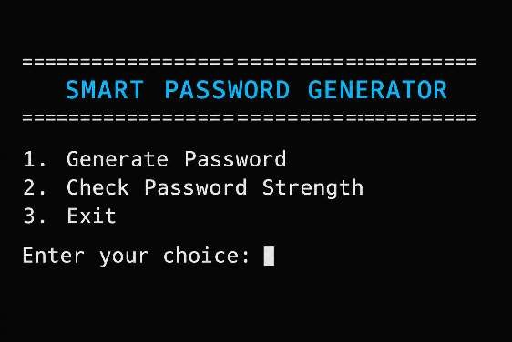
Figure 1: Main menu of the application

11.2 Password Generation
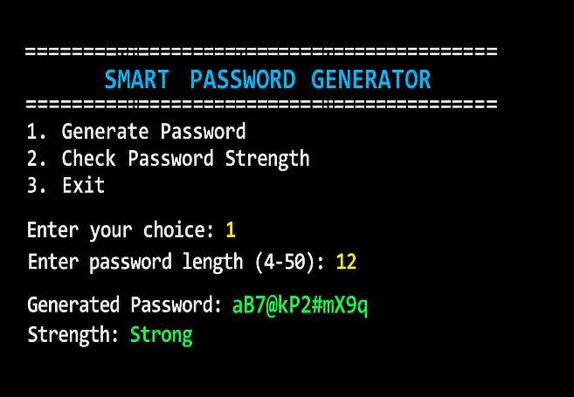
Figure 2: Generating a 12-character password

11.3 Password Strength Checking
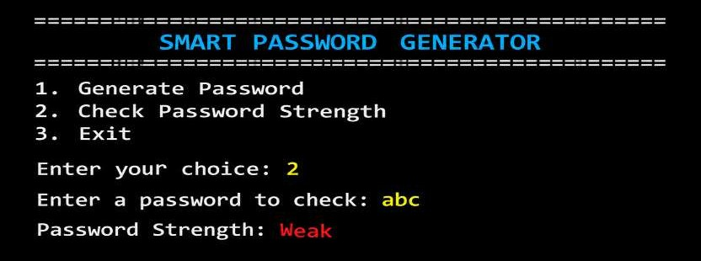
Figure 3: Checking the strength of the password "abc"

12. Code
import java.security.SecureRandom; import java.util.Scanner;
public class PasswordGenerator {
// Character sets used for password generation private static final String LOWERCASE = "abcdefghijklmnopqrstuvwxyz"; private static final String UPPERCASE = "ABCDEFGHIJKLMNOPQRSTUVWXYZ"; private static final String NUMBERS = "0123456789"; private static final String SYMBOLS = "!@#$%^&*()-_=+[]{};:,.<>?/"; private static final String ALL_CHARS = LOWERCASE + UPPERCASE + NUMBERS + SYMBOLS;
private static final SecureRandom random = new SecureRandom();
public static void main(String[] args) { Scanner sc = new Scanner(System.in); int choice;
do { System.out.println("\n========================================");
System.out.println(" SMART PASSWORD GENERATOR");
System.out.println("========================================");
System.out.println("1. Generate Password");
System.out.println("2. Check Password Strength");
System.out.println("3. Exit"); System.out.print("Enter your choice: ");
try { choice = Integer.parseInt(sc.nextLine().trim()); } catch (NumberFormatException e) { System.out.println("Invalid input. Please enter 1, 2 or 3."); choice = 0; continue; }
switch (choice) { case 1: System.out.print("Enter password length (4-50): "); int length; try { length = Integer.parseInt(sc.nextLine().trim()); } catch (NumberFormatException e) { System.out.println("Invalid length. Please enter a number."); break; }
if (length < 4 || length > 50) { System.out.println("Invalid length! Enter a value between 4 and 50."); break; }
String password = generatePassword(length);
System.out.println("Generated Password: " + password); System.out.println("Strength: " + checkStrength(password)); break;
case 2: System.out.print("Enter a password to check: ");
String input = sc.nextLine(); System.out.println("Password Strength: " + checkStrength(input)); break;
case 3: System.out.println("Thank you for using Smart Password Generator!"); break;
default: System.out.println("Invalid choice. Please select 1, 2 or 3.");
} } while (choice != 3); sc.close();
}
// Generates a random password containing all four character categories static String generatePassword(int length) { StringBuilder password = new StringBuilder();
// Guarantee at least one character from each category password.append(randomChar(LOWERCASE)); password.append(randomChar(UPPERCASE)); password.append(randomChar(NUMBERS)); password.append(randomChar(SYMBOLS));
// Fill the remaining positions from the combined character set for (int i = 4; i < length; i++) { password.append(randomChar(ALL_CHARS)); }
// Shuffle so the guaranteed characters are not always at the start for (int i = password.length() - 1; i > 0; i--) { int j = random.nextInt(i + 1); char temp = password.charAt(i); password.setCharAt(i, password.charAt(j)); password.setCharAt(j, temp); } return password.toString(); }
private static char randomChar(String chars) { return chars.charAt(random.nextInt(chars.length())); }
// Scores a password on length and character variety static String checkStrength(String password) { int score = 0; boolean lower = false, upper = false, digit = false, symbol = false;
if (password.length() >= 8) score++; if (password.length() >= 12) score++;
for (int i = 0; i < password.length(); i++) { char c = password.charAt(i); if (Character.isLowerCase(c)) lower = true; else if (Character.isUpperCase(c)) upper = true; else if (Character.isDigit(c)) digit = true; else symbol = true; }
if (lower) score++; if (upper) score++; if (digit) score++; if (symbol) score++;
if (score <= 3) return "Weak"; else if (score <= 5) return "Medium"; else return "Strong"; }
}

13. Advantages
- Simple and easy-to-use console interface.
- Generates random passwords of a user-specified length.
- Supports lowercase letters, uppercase letters, numbers, and special symbols.
- Uses Java's SecureRandom class for random character selection.
- Automatically evaluates password strength.
- Provides immediate feedback through Weak, Medium, and Strong classifications.
- Validates password length and menu inputs.
- Demonstrates fundamental Java programming concepts.
- Can be extended with additional features in the future.

14. Limitations
- The application operates only through a console-based interface.
- Password strength is evaluated using a simple scoring system.
- The application does not check passwords against known compromised-password databases.
- Generated passwords are not saved for future reference.
- The application does not provide user accounts or password management facilities.
- Users cannot currently customize the character categories included in generated passwords.
- The application does not provide advanced security analysis, such as detecting common password patterns or dictionary words.

15. Future Enhancements
- Develop a graphical user interface using Java Swing or JavaFX.
- Allow users to select the character categories used in password generation.
- Add an option to copy the generated password to the clipboard.
- Improve password strength evaluation by detecting common patterns and weak passwords.
- Add an option to generate multiple passwords at once.
- Provide a password history feature with appropriate security protections.
- Add password generation presets for different length requirements.
- Introduce secure password storage and password-management features.
- Improve input validation and error handling.

16. Conclusion
The Smart Password Generator & Strength Checker was developed as a simple console-based Java application for generating random passwords and evaluating their strength. The project demonstrates the practical application of Java programming concepts such as classes, methods, strings, loops, conditional statements, user input handling, and random character generation using the SecureRandom class.
The application allows users to generate passwords of a specified length using different character categories and evaluate existing passwords based on their length and character combinations. It provides a basic classification of password strength as Weak, Medium, or Strong. This project offers practical experience in Java programming and provides a foundation for developing more advanced password generation and security applications.

17. References
Oracle Java Documentation — https://docs.oracle.com/en/java/
Java SecureRandom Class Documentation — https://docs.oracle.com/en/java/javase/25/docs/api/ja va.base/java/security/SecureRandom.html
Java Scanner Class Documentation — https://docs.oracle.com/en/java/javase/25/docs/api/java.base /java/util/Scanner.html
Java StringBuilder Class Documentation — https://docs.oracle.com/en/java/javase/25/docs/api/java.
base/java/lang/StringBuilder.html
Java programming class notes and laboratory materials.

